**Project 1 – BANK LOAN ANALYSIS (Microsoft SQL SERVER, SQL Server Management Studio)  
functionalities which I learn in project**

**Task 1 :- Importing file and Making datbase  
------*Importing data file type.csv into SQL Server Management Studio**After opening the server 🡪 Open databases 🡪 right click (New Database) 🡪 writet name (e.g. Bank Loan DB) enter🡪 (Database will be get genrated)  
🡪 Right click on new database generated 🡪 Task 🡪 Import Flat File 🡪 Browse the fils 🡪 upload.csv file from internal storage 🡪

Right click on data base name 🡪 New Query  
  
**SELECT** * **FROM** table_name;

**SELECT** * **FROM** bank_loan_data; **Result :-** 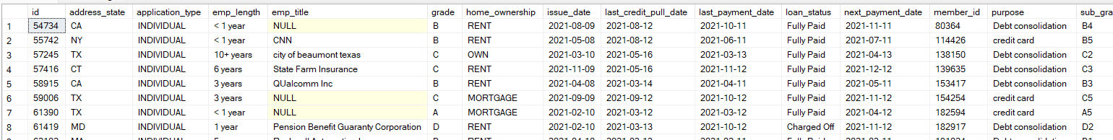

**Task 2 :- Firing Queries according to our problem statement   
  
1. Total Loan Applications**: We need to calculate the total number of loan applications received during a specified period. Additionally, it is essential to monitor the Month-to-Date (MTD) Loan Application and track changes Month-over-Month (MoM).  
  
**SELECT COUNT(id) FROM bank_loan_data;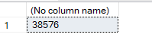 SELECT COUNT(id) AS Total_Loan_Applications FROM bank_loan_data;****-- 12 = December:  
SELECT COUNT(id) AS MTD_Total_Loan_Applications FROM bank_loan_data   
WHERE MONTH(issue_date) = 12 AND YEAR(issue_date) = 2021;  
***\*\*final script according to statement\*\****-- 11 = November, PMTD :- P = previous:**

**SELECT COUNT(id) AS PMTD_Total_Loan_Applications FROM bank_loan_data   
WHERE MONTH(issue_date) = 11 AND YEAR(issue_date) = 2021;  
**

**2. Total Funded Amount**: Understanding the total amount of funds disbursed as loan is crucial. We also want to keep an eye on the MTD Total Funded Amount and analyse the Month-over-Month (MoM) changes in the metric.  
**SELECT SUM(loan_amount) AS Total_Funded_Amount FROM bank_loan_data;** **SELECT SUM(loan_amount) AS MTD_Total_Funded_Amount FROM bank_loan_data  
WHERE MONTH(issue_date) = 12 AND YEAR(issue_date) = 2021;  
***\*\*final script according to statement\*\****-- 11 = November, PMTD :- P = previous:  
SELECT SUM(loan_amount) AS PMTD_Total_Funded_Amount FROM bank_loan_data  
WHERE MONTH(issue_date) = 11 AND YEAR(issue_date) = 2021;  
**

**3. Total Amount Received**: Tracking the total amount receive from borrowers is essential for assessing the bank’s cash flow and loan repayment. We should analyse the Month-to-Date (MTD) Total Amount Received and observe the Month-over-Month(MoM) changes.  
**SELECT SUM(total_payment) AS Total_Amount_Received FROM bank_loan_data;  
**

**SELECT SUM(total_payment) AS PMTD_Total_Amount_Received FROM bank_loan_data  
WHERE MONTH(issue_date) = 11 AND YEAR(issue_date) = 2021;  
**

**4. Average Interest Rate**: Calculating the average interest rate across all loans, MTD and monitoring the Month-over-Month (MoM) variation in interest rates will provide insights into our lending portfolio’s overall cost.  
**--. *100 because 0.something ;**

**SELECT AVG(int_rate) * 100 AS Avg_Interest_Rate FROM bank_loan_data;  
  
  
--. ROUND (AVG(int_rate), 4 <-- upto which decimal point) ;**

**SELECT ROUND(AVG(int_rate), 4) * 100 AS Avg_Interest_Rate FROM bank_loan_data;  
**

**SELECT ROUND(AVG(int_rate), 4) * 100 AS PMTD_Avg_Interest_Rate FROM bank_loan_data  
WHERE MONTH(issue_date) = 11 AND YEAR(issue_date) = 2021;  
**

**5. Average Depth-to-Income Ratio(DTI)**: Evaluating the average DTI for our borrowers helps usgauge their financial health. We need to compute the average DTI for all loans, MTD and track Month-over-Month (MoM) fluctuations.

**SELECT ROUND(AVG(dti),4) * 100 AS PMTD_Avg_DTI FROM bank_loan_data  
WHERE MONTH(issue_date) = 11 AND YEAR(issue_date) = 2021;  
  
Task 3:- Good Loan vs Bad Loan (KPIs)   
Good Loan**1. Good Loan Application Percentage  
**SELECT  
(COUNT(CASE WHEN loan_status = 'Fully Paid' OR loan_status = 'Current' THEN id END) *100)  
/  
COUNT(id) AS Good_loan_percentage  
FROM bank_loan_data;**   


2. Good Loan Application  
**SELECT COUNT(id) AS Good_Loan_Applications FROM bank_loan_data  
WHERE loan_status = 'Fully Paid' OR loan_status = 'Current';  
**   
3. Good Loan Funded Amount  
**SELECT SUM(loan_amount) AS Good_Loan_Funded_Amount FROM bank_loan_data**  
**WHERE loan_status = 'Fully Paid' OR loan_status = 'Current';**   
4. Good Loan Total Received Amount  
**SELECT SUM(total_payment) AS Good_Loan_Recieved_Amount FROM bank_loan_data**  
**WHERE loan_status = 'Fully Paid' OR loan_status = 'Current';**   


**BAD Loan**1. BAD Loan Application Percentage  
**SELECT  
(COUNT(CASE WHEN loan_status = 'Charged off' THEN id END) *100.0)  
/  
COUNT(id) AS Bad_loan_percentage  
FROM bank_loan_data;**  
2. BAD Loan Application  
**SELECT COUNT(id) AS Bad_Loan_Applications FROM bank_loan_data  
WHERE loan_status = 'Charged off';  
**  
3. BAD Loan Funded Amount  
**SELECT SUM(loan_amount) AS Bad_Loan_Funded_Amount FROM bank_loan_data**  
**WHERE loan_status = 'Charged off';**  
4. BAD Loan Total Received Amount  
**SELECT SUM(total_payment) AS Bad_Loan_Recieved_Amount FROM bank_loan_data**  
**WHERE loan_status = 'Charged off';**   


**Task 4 : Loan Status Grid View**In order to gain a comprehensive overview of our lending operations and monitor the performance of loans, we aim to create a grid view report categorized by ‘Loan Status’. By providing insights into metrics such as ‘Total Loan Applications’, ‘Total Funded Amount’, ‘Total Amount Received’, ‘Month-to-Date(MTD) Funded Amount, ‘MTD Amount Received’, ‘Average Interest Rate ‘and ‘Average Dept-to-income Ratio(DTI)’, this grid view will empower us to make data-driven decision and assess the health of your loan portfolio.

**--LOAN STATUS**

**SELECT**

**loan_status,**

**COUNT(id) AS Total_Loan_applications,**

**SUM(total_payment) AS Total_Amount_Received,**

**SUM(loan_amount) AS Total_Funded_Amount,**

**AVG(int_rate * 100) AS Interest_Rate,**

**AVG(dti * 100) AS DTI**

**FROM**

**bank_loan_data**

**GROUP BY**

**loan_status  
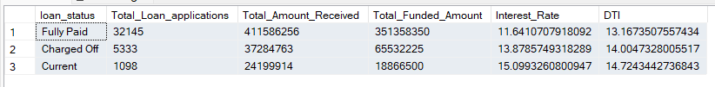**

**--MTD**

**SELECT**

**loan_status,**

**SUM(total_payment) AS MTD_Total_Amount_Received,**

**SUM(loan_amount) AS MTD_Total_Funded_Amount**

**FROM bank_loan_data**

**WHERE MONTH(issue_date) = 12**

**GROUP BY loan_status**

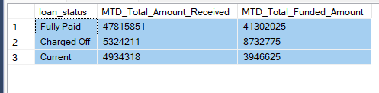

**Task 5 : Dashboard 2 overview || CHARTS  
1. Monthly Trends by Issue Date (Line Chart)**: To identify seasonality and long-term trends in lending activities.  
**SELECT**

**MONTH(issue_date) AS Month_Number,**

**DATENAME(MONTH, issue_date) AS Months,**

**COUNT(id) AS Total_Loan_Application,**

**SUM(loan_amount) AS Total_Funded_Amount,**

**SUM(total_payment) AS Total_Received_Amount**

**FROM bank_loan_data**

**GROUP BY MONTH(issue_date), DATENAME(MONTH, issue_date)**

**ORDER BY MONTH(issue_date)**

Result  
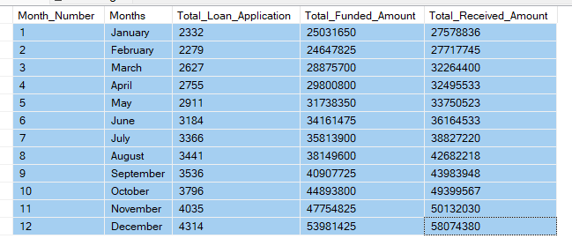  
**2. Regional Analysis by State (Filled Map):** To identify region with significant lending activity and assess regional disparities.

**SELECT**

**address_state,**

**COUNT(id) AS Total_Loan_Application,**

**SUM(loan_amount) AS Total_Funded_Amount,**

**SUM(total_payment) AS Total_Received_Amount**

**FROM bank_loan_data**

**GROUP BY address_state**

**ORDER BY address_state**Result  
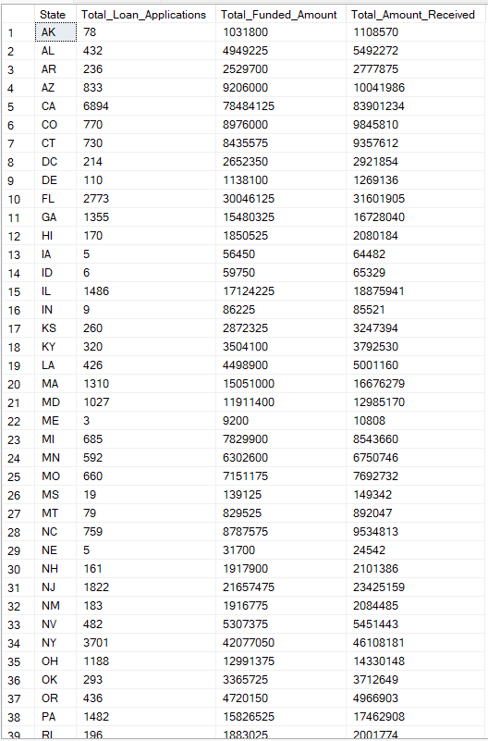

**3. Loan Term Analysis (Donut Chart)**: To allow the client to understand the distribution of loans across various term lengths.  
**SELECT**

**term,**

**COUNT(id) AS Total_Loan_Application,**

**SUM(loan_amount) AS Total_Funded_Amount,**

**SUM(total_payment) AS Total_Received_Amount**

**FROM bank_loan_data**

**GROUP BY term**

**ORDER BY term**Result  
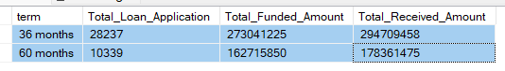  
  
**4. Employee Length Analysis (Bar Chart)**: How Lending metrics are distributed among borrowers with different employment lengths, helping us assess the impact of employment history on loan application.

**SELECT**

**emp_length,**

**COUNT(id) AS Total_Loan_Application,**

**SUM(loan_amount) AS Total_Funded_Amount,**

**SUM(total_payment) AS Total_Received_Amount**

**FROM bank_loan_data**

**GROUP BY emp_length**

**ORDER BY emp_length**Result

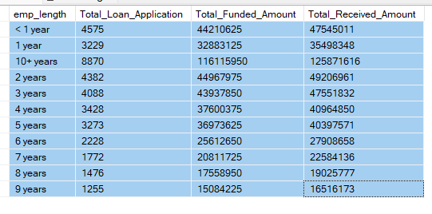  
  
  
**5. Loan purpose breakdown (Bar Chart)**: Will provide a visual breakdown of loan metrics based on the stated purposes of loans, aiding in the understanding of the primary reasons borrowers seek financing.  
**SELECT**

**Purpose,**

**COUNT(id) AS Total_Loan_Application,**

**SUM(loan_amount) AS Total_Funded_Amount,**

**SUM(total_payment) AS Total_Received_Amount**

**FROM bank_loan_data**

**GROUP BY purpose**

**ORDER BY purpose**Result  
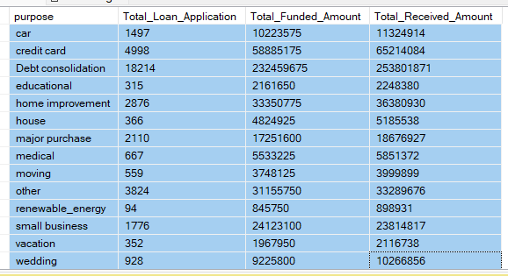

**6. Home Ownership Analysis (Tree Map)**: For a hierarchical view of how home ownership impacts loan applications and disbursements.  
**SELECT**

**home_ownership,**

**COUNT(id) AS Total_Loan_Application,**

**SUM(loan_amount) AS Total_Funded_Amount,**

**SUM(total_payment) AS Total_Received_Amount**

**FROM bank_loan_data**

**GROUP BY home_ownership**

**ORDER BY home_ownership**Result  
